U MENTAL HEALTH RESOURCE (UMHR)
Unisa Mental Health Resource Inc was founded on the back drop of a true story that mental health is a disease, that it is real and does not discriminate. The organization was named after a young man whose dreams of becoming a mechanical engineer was shattered by mental illness and eventually gave up by committing suicide. The organization later became UNIMED in 2023 after the passing his brother
WHAT WE DO
UMIMED is a 501(c)(3) organization that is dedicated to restore broken lives
through medical treatment, psychological therapy, skills treatment accommodation.
OUR HEROS
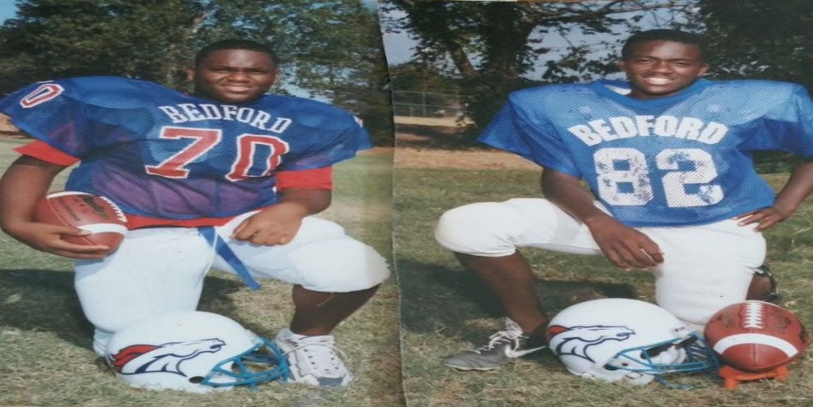
THE LATE UNISA PAUL BANGURA AND AHMED KEKEH JOE BANGURA RIPP
MEET OUR CEO AND CFO/FOUNDER
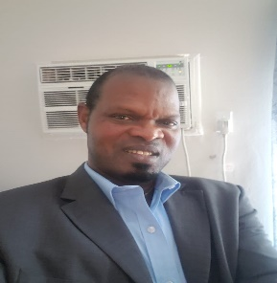

Dr Festus S Lahai
CEO
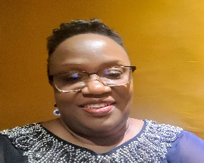
Doris Festus Lahai
FOUNDER/CFO
EET OUR BOARD MEMBERS
Ms Fatima Bangura
Mr Wilfred Kpandenyenge
Ms Roseline Jones

Meet our Management Team
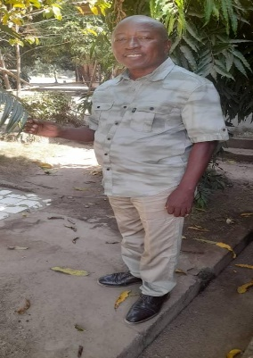
Mr Ben Lebbie
Program Manager
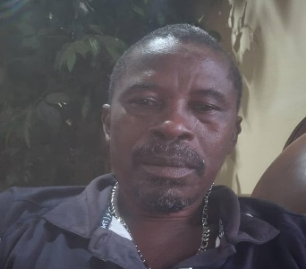
Mr Joseph Moitenga
Finance Officer

Mr Bashiru Sheriff
Progam Admistrator

Mrs. Doris Festus Lahai is the mother of Unisa Bangura and Ahmed Joe Bangura. She started her career as a confidential Secretary at the Sierra Leone Road Transport Corporation in Sierra Leone West Africa in 1985. She was also teacher of shorthand, typewriting and office practice at the St Joseph’s vocational school concurrently. She graduated from the Milton Margai Teachers College and relocated to the United States of America. In the United States, she worked as a Registered Nurse and a Nurse Practitioner at the Harris Methodist Hospital in Fort Worth Texas after her graduation
Mrs Doris Festus Lahai’s passion for the mentally ill persons started her two boys became mentally ill and she had deal with it alone until her eldest son Unisa committed suicide. Mrs Lahai had since committed to helping the mentally ill here in America and in Sierra Leone.
She lost her second son Ahmed Kekeh Joe Bangura in June of 2023 after a brief illness..
HISTORY
Unisa Mental Health Resource was founded on the back drop of a true story that mental health is a disease, that it is real and does not discriminate. The organization was named after a young man whose dreams of becoming a mechanical engineer was shattered by mental illness and eventually gave up by committing suicide. The mother who had only two boys and both were engulfed in the flames of mental illness decided to focus on methods to help restore other lives that have been attacked by a health condition that has been deprived of a caring attention and fed with stigma.
UMHR was established with monies that were saved by Unisa for 50th birthday. He was my greatest cheerleader and he was very proud of me. Unisa also under stands that her mother will do and spend a lot for others but never find time to the same for herself. Unisa decided to save monies in her piggy bank to celebrate my 50th birthday which supposed to be in March of 2013. Unisa had tpj[hold me that Ms. Doris as they ever called me, “I am going to give myself enough time to save this money because I will take no excuse for this celebration”. Unfortunately, Unisa committed suicide in October 2010. The monies Unisa had saved was used to establish this organization. This organization is therefore deeply rooted on the desire e desire to see provide effective care and services such that would have brought restoration to Unisa. The organization was formally established in 2013 and had since been funded by the founder and president.
Donations in the form of clothing and feeding was done to the Kissy Mental Home in 2014. The Organization also intermittently visit the homeless shelters in Fort Worth to donate food items.
A formal launching of the organization was done in October of 2018. This is our humble beginning and our prayer is to grow and impact many lives.
The name of the Organization changed to UNIMED after the death of her second child in June of 2023.
PURPOSE AND VISION
UMHR is a 501(c)(3) organization that is dedicated to advocate and serve individuals with an invisible wound. Together with our partners and Board, we will undertake programs that will inspire, develop, provide and support educational campaigns and programs that are geared towards good patient services and increased knowledge and understanding of mental illness while ensuring that the mentally ill persons have access to access to a quality care.
UMHR wants to ensure that lives and families are restored and free from the bondage of mental illness. By providing funding and a safe environment, that mentally ill persons can have an opportunity for self-examination, interaction with other mentally ill persons and counselling.
Our Vision
Together with our Board members, we will cater to the needs of the mentally ill persons through the provision of comprehensive coordinated programs and interventions that support the diagnosis, treatment, rehabilitation, skills and wellbeing of mentally ill persons residing in the United States, Sierra Leone and beyond.
UMHR will also embark on a national awareness and recognition of the challenges suffered by people living with this rare disease and sponsor access for all persons with substance abuse problems and other mental conditions to the diagnostics and therapies that will extend and improve their lives.
OUR PHILOSOPY
We believe that through the necessary education, and the creation of the right environment, man can have a positive change in behavior for the good of himself and others. Therefore, UMHR’s residential treatment center wherever located will be known as BETHEL a place where persons with substance abuse problems and other mental conditions can be treated, rehabilitated and empowered with the skill that can help them return to their communities as good citizens. Their encounter at BETHEL should help reduce behaviors or diseases that limits their independence and increase positive behaviors that empower a person and enhance opportunities for community, social, and family interaction.
OUR ORGANIZATION
UMHR is a non-profit 501(c)(3) organization that is designed to assist every person with mental illness and substance abuse problems to restore or stabilize their lives and assist them to transition into society effectively. UMHR Operates under15 Board of Directors. UMHR’s founder and Chief Executive Officer, Ms Doris Bangura- works in conjunction with the Board of Directors to plan and implement activities of the organization.
OUR Services
FOCUS ON SIERRA LEONE – WHY
According to the World Health Organization Report (WHO), Sierra Leone with a population of seven million has only two psychiatrists, two clinical psychologists and19 mental health nurses. Among these numbers, on four are specialized in child and adolescent mental health and no psychiatric social worker support (WHO, 2017). Mental Health is considered a silent crisis in Sierra Leone that has left the mentally challenged persons roaming the streets of Freetown due to inattention, poor mental health care, dilapidated facilities and amenities and shortage of qualified caregivers (the Sierra Leone Telegraph, 2015). One in four Sierra Leonean will be affected by mental illness in their life time (WHO, 2017). It is estimated that about 75,000 Sierra Leoneans will suffer from schizophrenia, 350,000 from depression but less than one percent of the countries global health related aids is allocated to mental health (WHO,2017). The country currently has only one psychiatric hospital with a maximum capacity of 120-bed (WHO, 2017). Interestingly, while the world health organization continues to work on a new mental health bill, Sierra Leone happens to have oldest mental act in the world which is the 1902 Lunacy Bill (WHO, 2017). The outdated Lunacy bill is a mental health act that has no provision for the right of a human being. Imagine if your healthcare in the 21st century is based on health care legislations of 1902 that includes nothing about your own right as a person. This is a clear indication that mental health persons in Sierra Leone are completely forgotten.

In a recent interview as part of my commitment of staying in touch, I was relieved to know that a Boston based charitable organization Partners In Health has undertaken a major refurbishment project in the form of structures. Four of the words which includes two male wards and two female wards have been completed and currently in use. We will therefore focus to help with environmental and patient hygiene as a short-term goal.
As a mother who continues to feel the sting of mental illness, I visited the Kissy Mental Home which is the only mental hospital in Sierra Leone. I saw first-hand, what has been stated by the world health organization and I decided to help. I will not help effectively without your support. Kindly help me bring dignity to Sierra Leone’s most forgotten citizens by your donation to my cause.

HOMELESSNESS
References
Improving access to mental health services in Sierra Leone. World Health Organization. Retrieved from: www.afro.who.int.countries. SL. News
Mental Health Data and Publication. Center For Disease Control and Prevention (2018). Retrieved from www.cdc.gov/mentalhealth/data.
Mental Health: the silent crisis in Sierra Leone. Sierra Leone Telegraph: 9 October 2015 (Retrieved from www.thesierraleonetelegraph.com

